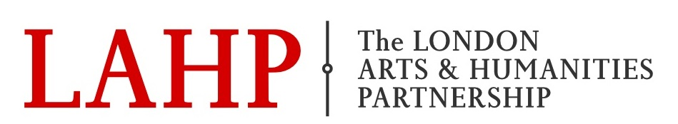

LAHP Placement Event
3rd February 2020 5.30 - 8pm
Victoria & Albert Museum

5.30pm | Hochhauser Auditorium | Registration, Tea & coffee
6pm | Hochhauser Auditorium | Talks:  6pm Prof. Alison Blunt – LAHP Introduction  6.10pm Elaine Tierney – V&A  6.20 Clara de Massol – LAHP Student (V&A Placement)  6.25pm Hannah Burke-Tomlinson – LAHP Student (Routledge Placement)  6.30pm Konrad Mould – AHRC IPS scheme
6.45 - 8pm | Seminar room 1 and Balcony space | Networking session  Elaine Tierney (V&A)  Catherine Souch (Royal Geographical Society)  Erin Lee (National Theatre)  Rachel Smillie (National Archives)  Ben Taylor (Cabinet Office)  Emily Miller (Migration Museum)  Katie Birkwood (Royal College of Physicians)  Bartek Dziadosz (Derek Jarman Lab)  Laura Humphreys (Science Museum)  Fin Kennedy (Tamasha Theatre Company)

