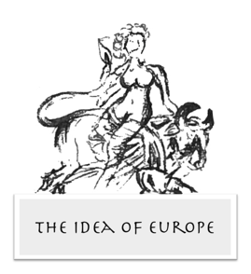
The Idea of Europe in Literature, Philosophy and the Arts: History and Current Debate

Thursday 5th March 2020
The Yellow Room, 18 Leather Lane, London

9:00-9:30 Registration

9:30-11:00 Session 1. Chair: Francesca Masiero (University College London)

Francesco Vitali (La Sapienza, Rome), Behind the Origin of Idea of Europe: the Historia dell' Europa of Pierfrancesco Giambullari

Rui Luis Rodrigues (Campinas State University), Orbis minima pars est Europa: Erasmian Humanism, Respublica Christiana and the non-European Roots of Europe

David Salomoni (University of Lisbon), Early Modern Nautical Rutters and the Idea of Europe: New Trends in Global and Digital History

11:00-11:10 Coffee Break

11:10-12:40 Session 2. Chair: Jack Hayes (University College London)

Peter D. Morgan (University College London), Stretching the Old Continent to the New: Domingo Sarmiento's Use of ‘Europe’ in 1840s Argentina

Martina Morabito (University of Genoa), Valentin Serov’s Oriental Europa in 1910

Kasia Szymanska (Trinity College Dublin), Experiments on Eastern Europe: Literary Imagination during Cold War

12:40-13:40 Lunch

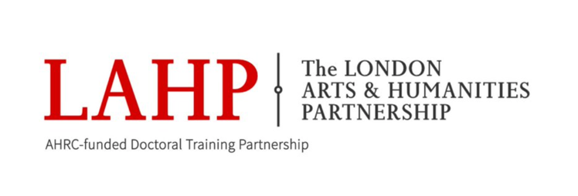

13:40-15:10 Session 3. Chair: Frederick Carnegy-Arbuthnott (University College London)

Michael J. Nixon (University of Oxford), From the Ruins, Our Common European Heritage: Music, Reconciliation, and Christian Discourses of Europe in Early Post-war Britain and Germany

Lefteris Spyrou (Institute for Mediterranean Studies), Promoting the Idea of Europe after WWII. The Council of Europe’s Art Exhibitions in the 1950s and 1960s

Megan Hoetger (Staatliche Kunstsammlungen Dresden), Screening Internationalism. Brussels and the Postwar International European Film Festival

15:10-15:20 Coffee Break

15:20-16:50 Session 4. Chair: Paolo Gattavari (University College London)

Stefano Bellin (University College London), The Conflictual Archipelago: On Massimo Cacciari’s Idea of Europe

Alexis Radisoglou (Durham University), On the Precarity of an Idea: Towards a Postfoundational Narrative of Europe

Anna Chichi (The Graduate Center, CUNY), Comparative Literature Stands for Europe

16:50-17:00 Coffee Break

17:00-18:00 Keynote speaker: Alex Drace-Francis (University of Amsterdam), Cultural History and the Idea of Europe: Prospects and Challenges for Research

Chair: Sarah Coviello (The Warburg Institute)

